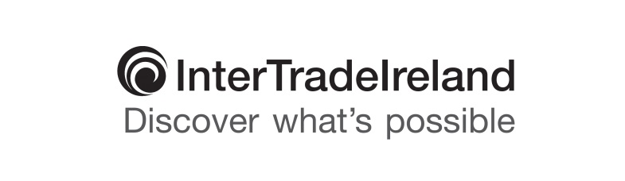

**Under embargo until Tuesday 30 August at 00.01**

**LATEST INTERTRADEIRELAND BUSINESS MONITOR REVEALS BUSINESSES ON BOTH SIDES OF THE BORDER UNPREPARED FOR BREXIT RESULT**

* At the time of the referendum 96% of businesses in Northern Ireland had no plans to deal with Brexit
* One in five (21%) of NI firms now expect to decrease their level/speed of planned investment
* One quarter (25%) of Northern Ireland companies think Brexit will have a negative impact on cross-border sales compared to more than half (57%) in Ireland
* More than a quarter of businesses on the island (27%) are concerned about exchange rates, an increase of 14% from quarter one
* Almost two thirds of Northern Ireland firms (62%) keen to continue to have access to the single market and free movement of people
* 90% of businesses across the island are growing or stable - 86% in Northern Ireland and 93% in Ireland

The latest quarterly Business Monitor Report (April - June 2016) released today illustrates, against the backdrop of generally positive business performance, that the outcome of the EU referendum has caught a large majority of businesses on the hop with 96% of businesses in Northern Ireland having no plan in place to deal with the consequences of a ‘leave’ vote.

There is a marked variation between companies in Northern Ireland and their counterparts in the Republic of Ireland in terms of the perceived Brexit impact on cross-border trade. While a quarter of businesses (25%) in the north felt that cross-border sales would decrease, more than twice as many Irish firms felt they would be negatively impacted (57%).

Nevertheless, the negative implications of a higher degree of uncertainty engendered in the marketplace by the decision are reflected in that one in five (21%) of Northern Ireland firms report that they plan to decrease their level or speed of investment.

Sectorally, too, there are variations. The hospitality industry is expecting a sharp decline in cross-border sales with 4 out of 5 (84%) companies expecting a downturn compared to around half of those in the manufacturing (49%), construction (52%) and servicing sectors (52%). Of those questioned, it appears that retail is the most positive with 15% anticipating an impact, perhaps due to exchange rate volatility. When broken down by size of company, almost half of small companies (46%) anticipate a decrease in sales compared to a third of large (33%) and medium (36%) companies.

There has also been a great deal of volatility and change in the relative importance of key issues facing businesses in comparison to quarter one. This quarter, the issues which have increased most in importance are exchange rates (up 14%), along with energy costs (up 8%), overhead costs (increased by 3%), a lack of skills (up 8%) and difficulty recruiting skills (increased by 10%). Other issues, including cash flow, new competitors and access to finance, remain important to many firms but dropped significantly in importance this quarter, which may be a first sign of the changing economic landscape post-referendum.

Regarding new relationships with the EU in the future, , around two thirds (62%) of NI businesses wish to retain access to the single market and the free movement of people.

Aidan Gough, Strategy and Policy Director at InterTradeIreland said: “It is evident in the responses to our latest Business Monitor that the outcome of the EU referendum has caught many businesses on the hop and introduced a large degree of uncertainty into the marketplace.

“Clearly businesses will need support particularly in the provision of timely and relevant information to assist them to adjust to any new trading relationships that emerge from BREXIT negotiations. In the short term, whilst companies will still trade under the same rules and regulations, we would encourage them to hedge any exposure their business may have to volatile movements in the Sterling / Euro exchange rate.

“InterTradeIreland will stay on the pulse of business needs and challenges through our Business Monitor so that we are in a position to respond quickly to business concerns and if necessary will adjust our supports as new trading rules and regulations emerge. We encourage businesses, particularly small and medium sized enterprises, to continue to exploit the cross-border market, taking a planned approach to export development or supply chain management.’’

In terms of wider business performance the picture remains generally positive. In Quarter 2, 86% of businesses in Northern Ireland report that they were stable or growing compared to 93% in Ireland. This differential between the two jurisdictions has increased from 5% in quarter one to 7% this quarter. There is also a more positive business position visible when comparing firms which take part in cross-border trade (where 48% are in slight, moderate or rapid growth mode), to only a third in growth mode who are not participating in trading outside their own jurisdiction.

Aidan concluded: “We may see uncertainty continuing in forthcoming quarters while companies adjust to changing realities. However it is encouraging that almost two thirds (65%) of businesses on the island state that they have ambition to grow in the immediate future. Resilience in the face of any adversity remains high and this can be seen across each of the sectors.”

For more information on InterTradeIreland and its business support programmes, please visit [www.intertradeireland.com](http://www.intertradeireland.com). A copy of the 2016 Q2 InterTradeIreland Business Monitor Executive Summary can be viewed at: <http://www.intertradeireland.com/researchandpublications/business_monitor/>

**ENDS**

For further information contact: Suzie Fisher, dcp strategic communication

T: 028 9037 0137 M: 07802 297240 E: [suzie@dcppr.co.uk](mailto:suzie@dcppr.co.uk)

**Notes to the Editor:**

InterTradeIreland’s quarterly Business Monitor survey is the largest and most comprehensive business survey on the island and is based on the views of more than 750 business managers across Northern Ireland and Ireland. ***Surveying for Q2 2016 began on 27 June 2016, the week after the referendum result.***

The Business Monitor differs from other surveys in that it is seen to be the ‘voice of local businesses’ feeding directly from telephone interviews conducted with firms of all sizes from across a range of sectors to track all-island economic indicators such as sales, employment, business outlook and other specific topical research areas on a quarter by quarter basis.

**Business Monitor Infographics and Slide Deck: Attached**

Attached to this press release is an infographic depicting key findings from the Q2 2016 Business Monitor Report for use and reference where applicable.

A copy of the 2016 Q2 InterTradeIreland Business Monitor Executive Summary Slide Deck can also be viewed at: http://www.intertradeireland.com/researchandpublications/business_monitor/